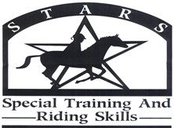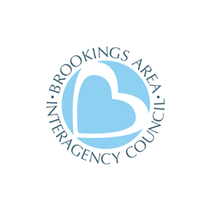

Spring, 2024

Dear Friend,
S.T.A.R.S. is so excited for another year of our riding program for people with special needs. What follows is a registration packet. Space is limited, so please register as soon as possible.

The purpose of S.T.A.R.S. is to provide opportunities for people ages 6 and older with special needs to achieve new successes in horsemanship. Riders will have one-on-one attention as they challenge themselves to accomplish their goals. Riders will be intentionally paired with a horse that will help them reach their aspirations.

There will be two sessions of S.T.A.R.S. this year. You may register for more than one session providing there is room. Each night there will be four slots of lessons. Riders will be assigned to a time slot based on skill level and first come, first served basis. We ride at the Circle H Stables (1510 28th Ave. West, Brookings, SD 57006).

Session Choice: (Mark as many as you wish to participate in.) Please mark your preference for riding time. (1 for first choice and 2 for second choice) Please Note: Due to unpredictable spring weather, we may need to adjust the session schedule. We will be in contact.

_____ Session #1, Ride #1 $80.00 June 4, 6, 11, 13, 18, 20, 25, 27 5:30-6:00 PM
_____ Session #1, Ride #2 $80.00 June 4, 6, 11, 13, 18, 20, 25, 27 6:00-6:30 PM
_____ Session #1, Ride #3 $80.00 June 4, 6, 11, 13, 18, 20, 25, 27 6:30-7:00 PM
_____ Session #1, Ride #4 $80.00 June 4, 6, 11, 13, 18, 20, 25, 27 7:00-7:30 PM
Make up rides July 9 & 11

_____ Session #2, Ride #1 $80.00 July 16, 18, 23, 25, 30, August 1, 6, 8 5:30–6:00 PM
_____ Session #2, Ride #2 $80.00 July 16, 18, 23, 25, 30, August 1, 6, 8 6:00-6:30 PM
_____ Session #2, Ride #3 $80.00 July 16, 18, 23, 25, 30, August 1, 6, 8 6:30-7:00 PM
_____ Session #2, Ride #4 $80.00 July 16, 18, 23, 25, 30, August 1, 6, 8 7:00-7:30 PM
Make up rides August 13 & 15

Please Note: Due to unpredictable spring weather, we may need to adjust the session schedule. We will be in contact.

The fee per session is $80. There is a discount for multiple-family members participating (2 family members for $120.00). To help defray the registration fee, contact Kristi for agencies/organizations that may be able to help with
the registration fees. If you need scholarship assistance, please contact Kristi (contact information is listed below).

Riding boots are preferred for safety. At the minimum, closed toe and enclosed heels are mandatory.
Intent to disrupt, harm, or harass staff, volunteers, or horses will not be tolerated.

WARNING: Under South Dakota law, and equine professional is not liable for an injury to or the death of a participant in equine activities resulting from the inherent risks of equine activities, pursuant to 42-11-2.

Please direct your questions to Kristi, S.T.A.R.S. Program Director.
Contact information: 1-605-736-2196 or brookingsstars.director@gmail.com
Please return your registration form to: Pat Connors @ Advance OR brookingsstars.director@gmail.com

We are excited to share this experience with you!

