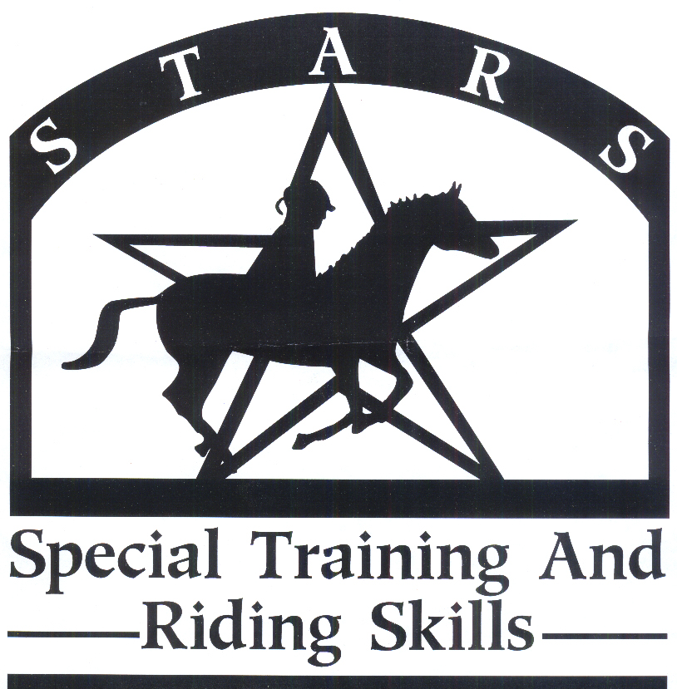
2023 S.T.A.R.S. Volunteer Registration Form

Please Print
Name:  Age: _____________ |  | Home Phone:  Cell Phone:  Email:
Address: | City: |  |  | State: |  | Zip:
How did you learn about STARS?
Do you have CPR training? ____ Yes ____ No  Have you been certified in the past? ____Yes ___No |  |  | Do you have First Aid Training? _____ Yes _____ No  Have you been certified in the past? ____Yes ____No
Check which areas you are interested in: (check as many as apply)

___ Working with horses ___ Working with Fund Raising ___ Working with Volunteer Recruitment

___ Working with participants ___ Working with Public Relations ___ Other ________________________

Photo Release
I consent to and authorize the use and reproduction by S.T.A.R.S. of all photographs and any other audio/visual materials taken of me for promotional printed materials, social media, educational activities, exhibitions, or any other use for the benefit of the program.
Date: | Signature:

In Case of Emergency
Please Print
Contact Name: |  |  | Home/Cell Phone: | Work Phone:
Physician: |  |  | Phone: | Hospital and Town:
 | In case of emergency, I give permission to S.T.A.R.S. to secure medical treatment including x-ray, surgery, hospitalization, medication, and transportation if needed.
 | Date: | Signature:
2023 S.T.A.R.S. Page 2
A Program of the Brookings Area Interagency Council

Volunteer Name: _________________________________________

May we release your contact information to committee chairs? ______ YES _____NO

Long pants only; shorts will not be allowed. Riding boots are preferred for safety. At the minimum, closed toe and enclosed heels are mandatory.
Intent to disrupt, harm, or harass staff, volunteers, or horses will not be tolerated.
If you are not feeling well, please notify the director.

If you have had a background check, please submit a copy if possible. If not, please go to a South Dakota Clerk of Courts office and request one. It is free.
If you have turned one in previously, you do not need to re-submit.

Volunteer Liability Release
Volunteers shall be 16 years or older. If a volunteer is under 16, the volunteer must have guardian supervision. As a volunteer at S.T.A.R.S. I acknowledge the risks and potential for risks of a horseback riding program. However, I feel that the possible benefits to myself and the participants I work with are greater than the risk assumed. I, therefore, intending to be legally bound, for myself, my heirs and assignees, executors, or administrators, waive and release forever all claims for damages against S.T.A.R.S., its board of directors, instructors, therapists, volunteers and/or employees for any and all injuries and/or losses I may sustain while participating in S.T.A.R.S.

Date: | Volunteer/ Guardian Signature:
WARNING: Under South Dakota law, an equine professional is not liable for any injury to or the death of a participant in equine activities resulting from the inherent risks of equine activities, pursuant to 42-11-2.

Do you have horse experience? Yes ______ No ______

Explain: __________________________________________________________________________________

_______________________________________________________________________________________________

Do you have experience working with individuals with challenges? Yes _____ No _____

Explain: __________________________________________________________________________________

_______________________________________________________________________________________________

2023 S.T.A.R.S. Page 3
A Program of the Brookings Area Interagency Council

Volunteer Name: _________________________________________

Please check all the times you would be available to volunteer. Put a line through the dates you will not be able to volunteer. Please Note: Due to unpredictable spring weather, we may need to adjust the session schedule. We will be in contact.

- _____ Session #1, Ride #1 May 30, June 1, 6, 8, 13, 15, 20, 22 5:30-6:30 PM
- _____ Session #1, Ride #2 May 30, June 1, 6, 8, 13, 15, 20, 22 6:30-7:30 PM
- _____ Session #1, Ride #1 Possible make-up rides June 27, 29 5:30-6:30 PM
- _____ Session #1, Ride #2 Possible make-up rides June 27, 29 6:30-7:30 PM

- _____ Session #2, Ride #1 July 11, 13, 18, 20, 25, 27, August 1, 3 5:30-6:30 PM
- _____ Session #2, Ride #2 July 11, 13, 18, 20, 25, 27, August 1, 3 6:30-7:30 PM
- _____ Session #2, Ride #1 Possible make-up rides August 8, 10 5:30-6:30 PM
- _____ Session #2, Ride #2 Possible make-up rides August 8, 10 6:30-7:30 PM

- _____ Session #3, Ride #1 August 15, 17, 22, 24, 29, 31 September 5, 7 5:30-6:30 PM
- _____ Session #3, Ride #2 August 15, 17, 22, 24, 29, 31 September 5, 7 6:30-7:30 PM
- _____ Session #3, Ride #1 Possible make-up rides September 12, 14 5:30-6:30 PM
- _____ Session #3, Ride #2 Possible make-up rides September 12, 14 6:30-7:30 PM

Volunteer Orientation Sign-Up

Training is mandatory for our Insurance Provider and to ensure a safe environment for everyone.
Please check your preference for attending training. Training location is @ Circle H Stables, 1510 28th Ave. West, Brookings, SD 57006. Attend one, two, or all sessions.

____ Tuesday, May 23 @ 5:30 PM
____ Wednesday, May 24 @ 5:30 PM
____ Thursday, May 25 @ 5:30 PM

- T-Shirt Size: (Please Circle One)

SM MED LG XLG XXLG XXXLG

Kristine Skorseth, Program Director
3413 Co Hwy 1
Hendricks, MN 56136
(605) 690-0259
Brookingsstars.director@gmail.com

