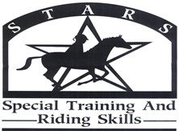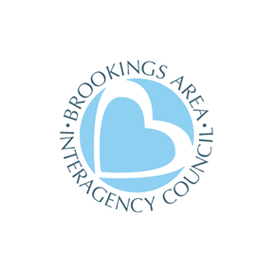

Spring, 2023

Dear Friend,
S.T.A.R.S. is so excited for another year of our riding program for people with special needs. What follows is a registration packet. Space is limited, so please register as soon as possible.

The purpose of S.T.A.R.S. is to provide opportunities for people ages 6 and older with special needs to achieve new successes in horsemanship. Riders will have one-on-one attention as they challenge themselves to accomplish their goals. Riders will be intentionally paired with a horse that will help them reach their aspirations.

There will be three sessions of S.T.A.R.S. this year. You may register for more than one session providing there is room. Each night there will be two slots of lessons. Riders will be assigned to a time slot based on skill level and first come, first served basis. We ride at the Circle H Stables (1510 28th Ave. West, Brookings, SD 57006).

Session #1 Ride #1 will be Tuesdays and Thursdays May 30, June 1, 6, 8, 13, 15, 20, 22 5:30-6:30 PM
Session #2 Ride #2 will be Tuesdays and Thursdays May 30, June 1, 6, 8, 13, 15, 20, 22 6:30-7:30 PM
Make up rides June 27 and 29 due to weather cancellations
Session #2 Ride #1 will be Tuesdays and Thursdays July 11, 13, 18, 20, 25, 27, August 1, 3 5:30-6:30 PM
Session #2 Ride #2 will be Tuesdays and Thursdays July 11, 13, 18, 20, 25, 27, August 1, 3 6:30-7:30 PM
Make up rides August 8 and 10 due to weather cancellations

Session #3 Ride #1 will be Tuesdays and Thursdays August 15, 17, 22, 24, 29, 31, September 5, 7 5:30-6:30 PM
Session #3 Ride #2 will be Tuesdays and Thursdays August 15, 17, 22, 24 ,29, 31, September 5, 7 6:30-7:30 PM
Make up rides September 12 and 14 due to weather cancellations
Please Note: Due to unpredictable spring weather, we may need to adjust the session schedule. We will be in contact.

The fee per session is $55. There is a discount for multiple-family members participating (2 family members for $90.00). If you need scholarship assistance, please call (1-605-690-0259), or email the S.T.A.R.S. Director, Kristine Skorseth, brookingsstars.director@gmail.com to request a scholarship.

Riding boots are preferred for safety. At the minimum, closed toe and enclosed heels are mandatory.
Intent to disrupt, harm, or harass staff, volunteers, or horses will not be tolerated.

WARNING: Under South Dakota law, and equine professional is not liable for an injury to or the death of a participant in equine activities resulting from the inherent risks of equine activities, pursuant to 42-11-2.

Please direct your questions to Kristine, S.T.A.R.S. Program Director.
Contact information: 1-605-690-0259 or brookingsstars.director@gmail.com
Please return your registration form to: Pat Connors @ Advance OR to Kristine Skorseth, 3413 Co Hwy 1, Hendricks, MN 56136 OR brookingsstars.director@gmail.com

We are excited to share this experience with you!

Kristine Skorseth, S.T.A.R.S. Program Director
3413 Co Hwy 1
Hendricks, MN 56136
605.690.0259
Brookingsstars.director@gmail.com starsbrookings.org

