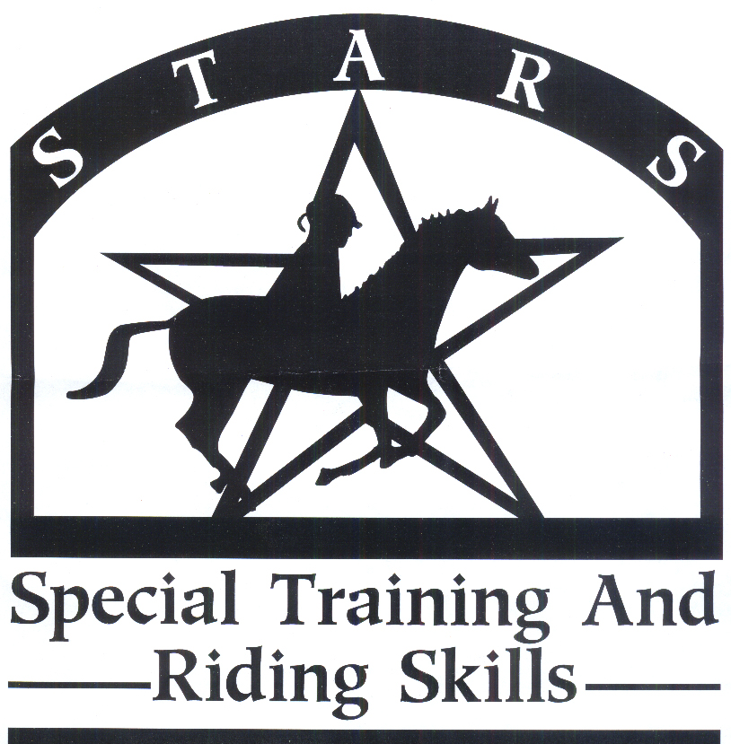
2022 S.T.A.R.S. Volunteer Registration Form
Please Print
Name:  Age: _____________ |  | Home Phone:  Email: _______________________ |  | Cell Phone:
Address: | City: |  | State: |  | Zip:
How did you learn about STARS?
Do you have CPR training? ____ Yes ____ No |  |  | Do you have First Aid Training? _____ Yes _____ No
Check which areas you are interested in: (check as many as apply)

___ Working with horses ___ Working with Fund Raising ___ Working with Volunteer Recruitment

___ Working with participants ___ Working with Public Relations ___ Other ________________________

Photo Release
I consent to and authorize the use and reproduction by S.T.A.R.S. of all photographs and any other audio/visual materials taken of me for promotional materials, educational activities, exhibitions, or any other use for the benefit of the program.
Date: | Signature:

Volunteer Liability Release
Volunteers shall be 16 years or older. If a volunteer is under 16, the volunteer must have guardian supervision. As a volunteer at S.T.A.R.S. I acknowledge the risks and potential for risks of a horseback riding program. However, I feel that the possible benefits to myself and the participants I work with are greater than the risk assumed. I, therefore, intending to be legally bound, for myself, my heirs and assignees, executors, or administrators, waive and release forever all claims for damages against S.T.A.R.S., its board of directors, instructors, therapists, volunteers and/or employees for any and all injuries and/or losses I may sustain while participating in S.T.A.R.S.
Date: | Volunteer/ Guardian Signature:
WARNING: Under South Dakota Law, an Equine professional is not liable for any injury to or the death of a participant in Equine activities resulting from the inherent risks of Equine activities, Pursuant to 42-11-2.

If you have had a background check, please submit a copy if possible. If not, please go to a South Dakota Clerk of Courts office and request one. It is free.

2022 S.T.A.R.S.
A Program of the Brookings Area Interagency Council

Volunteer Name: _________________________________________
In Case of Emergency
Please Print
Contact Name: |  |  | Home/Cell Phone: | Work Phone:
Physician: |  |  | Phone: | Hospital and Town:
 | In case of emergency, I give permission to S.T.A.R.S. to secure medical treatment including x-ray, surgery, hospitalization, and medication.
 | Date: | Signature:

Please check all the times you would be available to volunteer.

- _____ Session #1, Ride #1 May 31, June 2, 7, 9, 14, 16, 21, 23 5:30-6:30 PM
- _____ Session #1, Ride #2 May 31, June 2, 7, 9, 14, 16, 21, 23 6:30-7:30 PM
- _____ Session #1, Possible make-up rides June 28, 30 5:30-6:30 PM
- _____ Session #1, Possible make-up rides June 28, 30 6:30-7:30 PM

- _____ Session #2, Ride #1 July 12, 14, 19, 21, 26, 28, August 2,4 6:00-7:00 PM
- _____ Session #2, Ride #2 July 12, 14, 19, 21, 26, 28, August 2,4 7:00-8:00 PM
- _____ Session #2, Possible make-up rides August 9, 10 6:00-7:00 PM
- _____ Session #2, Possible make-up rides August 9, 10 7:00-8:00 PM

- _____ Session #3, Ride #1 August 16, 18, 23, 25, 30, September 1, 6, 8 5:30-6:30 PM
- _____ Session #3, Ride #2 August 16, 18, 23, 25, 30, September 1, 6, 8 6:30-7:30 PM
- _____ Session #3, Possible make-up rides September 13, 15 5:30-6:30 PM
- _____ Session #3, Possible make-up rides September 13, 15 6:30-7:30 PM
Volunteer Orientation Sign-Up
Training is mandatory for our Insurance Provider and to insure a safe environment for everyone.
Please check your preference for attending training. Training location is @ Circle H Stables, 1510 28th Ave. West, Brookings, SD 57006. Attend one, two, or all sessions.

- ____ Tuesday, May 24 @ 5:30 PM T-Shirt Size: (Please Circle One)
- ____ Wednesday, May 25 @ 5:30 PM SM MED LG XLG XXLG XXXLG
- ____ Thursday, May 26 @ 5:30 PM

Kristine Skorseth, Program Director
3405 6th St., Suite #4
Brookings, SD 57006
(605) 690-0259
Brookingsstars.director@gmail.com

