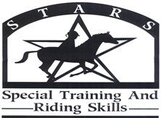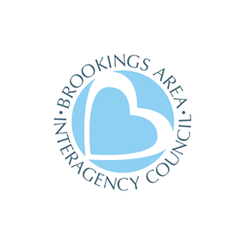

Spring, 2022

Dear Friend,
S.T.A.R.S. is so excited for another year of our riding program for people with special needs. What follows is a registration packet.
Registration is first come, first served. Space is limited, so please register as soon as possible.
The purpose of S.T.A.R.S. is to provide opportunities for people ages 6 and older with special needs to achieve new successes in horsemanship. Riders will have one-on-one attention as they challenge themselves to accomplish their goals. Riders will be intentionally paired with a horse that will help them reach their aspirations.
There will be three sessions of S.T.A.R.S. this year. You may register for more than one session providing there is room. Each night there will be two slots of lessons. Riders will be assigned to a time slot based on the first come, first served basis. We ride at the Circle H Stables (1510 28th Ave. West, Brookings, SD 57006).

Session #1 Ride #1 will be Tuesdays and Thursdays May 31, June 2, 7, 9, 14, 16, 21, 23 5:30-6:30 PM
Session #2 Ride #2 will be Tuesdays and Thursdays May 31, June 2, 7, 9, 14, 16, 21, 23 6:30-7:30 PM
Make up rides June 28 and 30 due to weather cancellations
Session #2 Ride #1 will be Tuesdays and Thursdays July 12, 14, 19, 21, 26, 28, August 2, 4 6:00–7:00 PM
Session #2 Ride #2 will be Tuesdays and Thursdays July 12, 14, 19, 21, 26, 28, August 2, 4 7:00-8:00 PM
Make up rides August 9 and 10 due to weather cancellations

Session #3 Ride #1 will be Tuesdays and Thursdays August 16, 18, 23, 25 ,30, September 1, 6, 8 5:30-6:30 PM
Session #3 Ride #2 will be Tuesdays and Thursdays August 16, 18, 23, 25 ,30, September 1, 6, 8 6:30-7:30 PM
Make up rides September 13 and 15 due to weather cancellations

The fee per session is $40. There is a discount for multiple-family members participating (2 family members for $60.00). If you need scholarship assistance, please call (1-605-690-0259), or email the S.T.A.R.S. Director, Kristine Skorseth, brookingsstars.director@gmail.com to request a scholarship.
Please direct your questions to Kristine, S.T.A.R.S. Program Director.
Contact information: 1-605-690-0259 or brookingsstars.director@gmail.com
Please return your registration form to: Pat Connors @ Advance OR to Kristine Skorseth, 3405 6th St., Suite 4, Brookings, SD 57006 OR brookingsstars.director@gmail.com

We are excited to share this experience with you!

-Kristine Skorseth, S.T.A.R.S. Program Director

